Strawberry Grow Bags

Our strawberry Grow bags, which contain our specifically developed and buffered Precision Plus grade, are made with the plant, and the grower, in mind. We wash and buffer our coir to a very high standard, so that when the young strawberry plants are planted in the grow bag, they are in the best environment to promote growth.

The Precision Plus Ultra mix that we use for our strawberry grow bags has been developed with 3 specifically chose particle sizes to give an open structure and more aeration.

This structure means that the opportunity for re-use is maximised, and it enables growers to steer the crop by controlling the moisture level in the bag. It is also very quick to hydrate.
The stringent quality control procedures in our production facility mean that we are constantly testing the products, and making sure that the pH, calcium, sodium, boron, magnesium, chloride, silicon, EC and potassium levels are within the range of standards as recommended for strawberry cultivation in coir.
We make each product specifically to the growers needs, from the coir mix and buffering to the plastic of the bag.

We can make the grow bags in sizes up to 120cm in length with width and height as required.

We are equally flexible on the planting, dripper and drainage holes that we can pre-cut in the grow bag, if required, at no extra cost.

We also have the ability to drill holes, as required, directly into the coir at dripper points to facilitate wetting up the slabs.

All of the plastic that we use is high quality, UV treated and recyclable.

We offer both white and black plastic to suit different climates, giving the grower the option to gain the extra heat absorbed by black plastic for early picking if required.

Strawberry Grow Bags

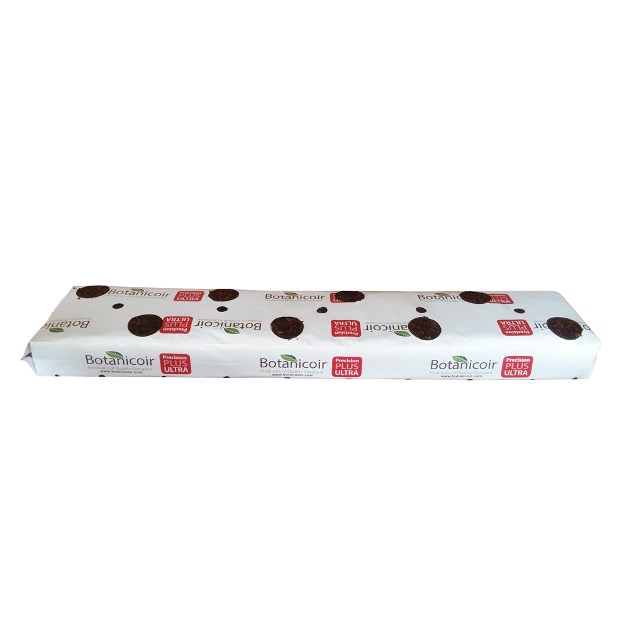
4 or 8 Holes
+ Drainage Holes & Dripper Holes
100 x 20 x 8cm
Bags available in White or Black
550 Units per Pallet

